Activity No. <n>
<Replace with Title>
Course Code: CPE010 | Program: Computer Engineering
Course Title: Data Structures and Algorithms | Date Performed: August 28, 2025
Section:CPE21S4 | Date Submitted: August 28, 2025
Name(s): Bautista,Mariela S. | Instructor: Engr.Quejado
6. Output
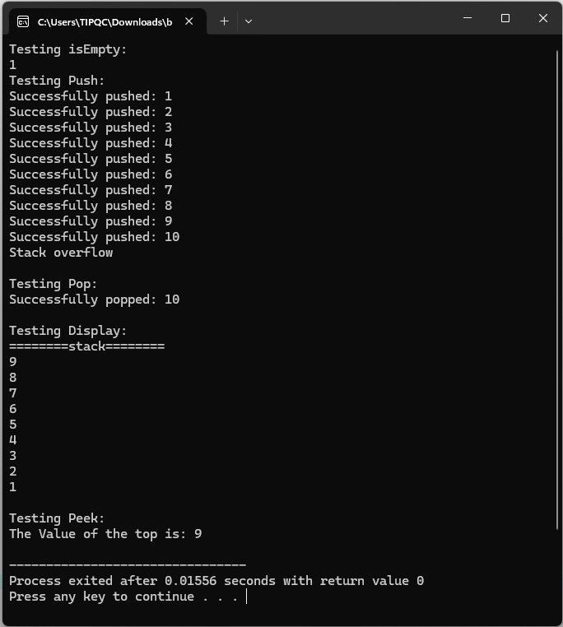
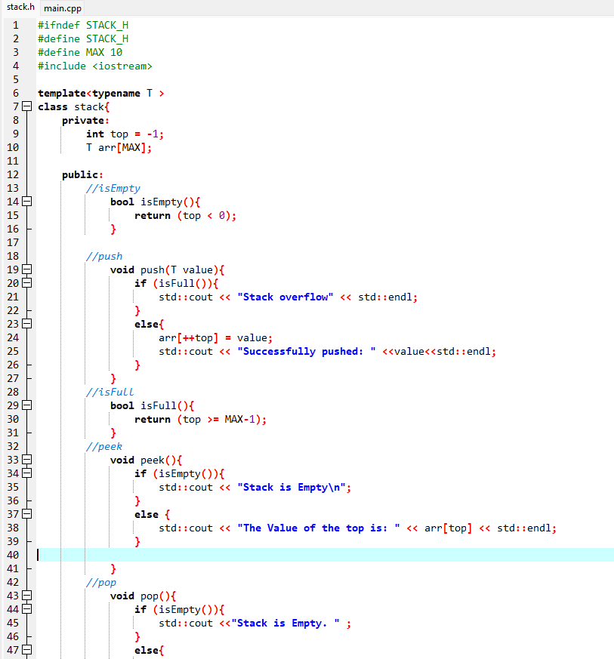
7. Supplementary Activity
Header File:

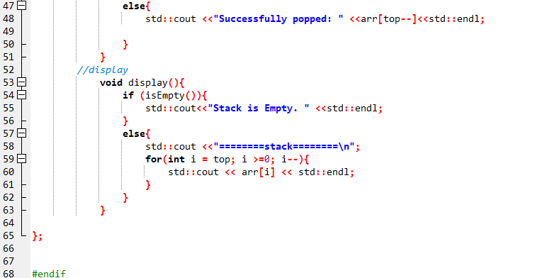

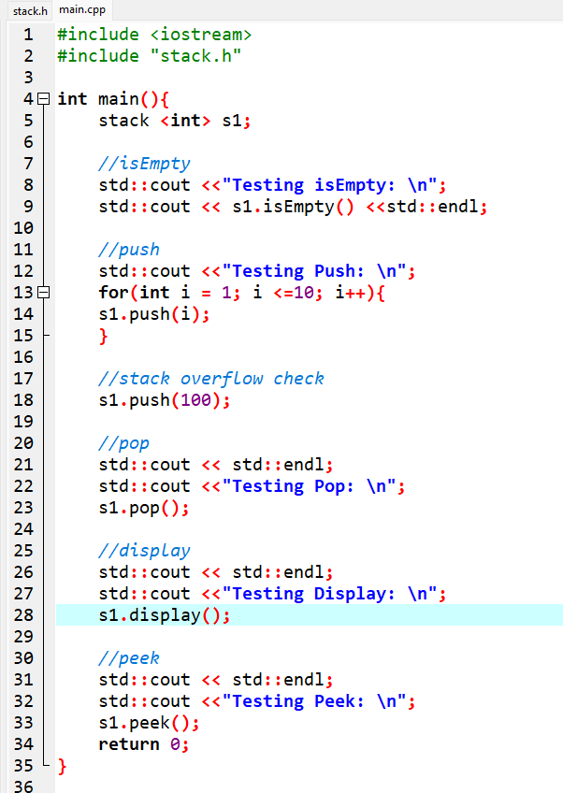
Main.cpp
8. Conclusion
What I have Learned in Todays learning is how stacks are using templates in C++. It covers essential stack operations such as push, pop, peek, and display, along with overflow and underflow checks. Overall, it provides a solid foundation for understanding stack behavior and generic and still kind of basic take in programming.
9. Assessment Rubric

